PROJECT BASED LEARNING
ON
Diabetic Prediction
Submitted in partial fulfillment of the requirement for the award of the degree of

BACHELOR OF TECHNOLOGY
in
ARTIFICIAL INTELLIGENCE AND DATA SCIENCE
AT
DELHI TECHNICAL CAMPUS GREATER NOIDA

SUBMITTED BY
Piyush Joshi – 02318011923
Divytosh upadhay-35518011923

AIML/AIDS, (5th )
(2026-27)
SUBMITTED TO

Ms. SUDHA

Department of Artificial Intelligence SESSION 2024


DELHI TECHNICAL CAMPUS, GREATER NOIDA
(Affiliated by Guru Gobind Singh Indraprastha University, New Delhi)

ACKNOWLEDGEMENT
We would like to express our sincere gratitude to our respected faculty and mentors for their continuous guidance, motivation, and support throughout the completion of our project “Diabetes Prediction using Machine Learning.”
We are especially thankful to our project guide and department for providing us with the necessary resources and a learning environment that encouraged innovation and research. Their valuable feedback helped us improve the quality and depth of our work.
We would also like to thank our friends and classmates for their cooperation and constant encouragement during the development of this project.
Finally, we express our heartfelt thanks to our families for their patience, love, and support throughout this journey.
Submitted by:
Piyush Joshi
Divytosh Upadhyay
B.Tech – Artificial Intelligence and Data Science

TABLE OF CONTENT

S.No. | TITLE | Page No.
1. | Acknowledgment | 2
2. | Introduction | 3
3. | Problem Statement | 4
4. | Objective | 7
5. | Methodology | 6
6. | Result | 11
7. | Conclusion | 12
8. | Future | 13
9. | References | 14

INTRODUCTION

Introduction –
Diabetes mellitus is one of the most common and serious metabolic disorders affecting millions of people worldwide. It occurs when the human body is unable to regulate blood glucose levels effectively, leading to either high (hyperglycemia) or low (hypoglycemia) blood sugar levels. Uncontrolled diabetes can cause severe health complications such as heart disease, kidney failure, and nerve damage.
With the rapid growth of healthcare data and advancements in artificial intelligence, machine learning (ML) has become a powerful tool in the field of medical diagnosis and prediction. ML algorithms can analyze large amounts of patient data, identify hidden patterns, and predict the likelihood of diseases with high accuracy.
The objective of this project is to develop a machine learning-based prediction system that can accurately determine whether a person is likely to have diabetes based on various medical parameters such as Glucose level, BMI, Age, Blood Pressure, Insulin, and Family history.
The project utilizes the PIMA Indian Diabetes Dataset, preprocesses the data, trains multiple ML models, and evaluates their performance to find the most efficient and accurate model. A Flask-based web application is also developed to allow users to input their health details and instantly receive prediction results.
This system aims to assist healthcare professionals and individuals by providing an early warning mechanism for diabetes, encouraging timely diagnosis and preventive care.

Problem Statement
Diabetes is a chronic disease that can lead to serious health complications if not diagnosed and managed at an early stage. Traditional diagnosis methods require medical testing and manual interpretation, which can be time-consuming, costly, and prone to human error.
With the increasing availability of healthcare data, there is a growing need for an automated, data-driven system that can accurately predict the likelihood of diabetes based on key health indicators such as glucose level, BMI, blood pressure, insulin level, and age.
The problem addressed in this project is:
How can machine learning algorithms be used to accurately predict whether a person is diabetic or non-diabetic based on clinical and physiological parameters?
The goal is to develop a reliable, efficient, and user-friendly prediction system that assists both healthcare professionals and individuals in making early and informed health decisions.

Objective
he main objectives of the project “Diabetes Prediction using Machine Learning” are as follows:
- To analyze the diabetes dataset and understand the relationship between various health parameters such as Glucose, BMI, Age, and Blood Pressure.
- To preprocess and clean the dataset by handling missing or invalid values for better model accuracy.
- To implement different machine learning algorithms like Logistic Regression, Random Forest, SVM, and Decision Tree for diabetes prediction.
- To evaluate the performance of these models using metrics such as accuracy, precision, recall, and F1-score.
- To identify the most accurate and reliable algorithm for diabetes prediction.
- To develop a user-friendly web application using Flask that allows real-time prediction based on user input.
- To visualize data insights and model results using interactive graphs and charts.
- To contribute towards early diagnosis and prevention of diabetes through the use of artificial intelligence.

Methodology
he methodology for the project “Diabetes Prediction using Machine Learning” involves several systematic steps to ensure accurate data analysis, model building, and prediction. The process can be divided into the following phases:
1. Data Collection
The project uses the PIMA Indian Diabetes Dataset, which contains medical data of female patients aged 21 years and above. The dataset includes eight independent features such as Glucose, BMI, Blood Pressure, Insulin, and Age, and one target variable — Outcome (0 = Non-Diabetic, 1 = Diabetic).
2. Data Preprocessing
Before training the model, the dataset was cleaned and prepared to improve model performance:
- Replaced missing or zero values in columns like Glucose, Blood Pressure, and BMI.
- Normalized numerical features to maintain a uniform scale.
- Split the data into 80% training and 20% testing subsets for model validation.
3. Feature Selection
Analyzed the correlation between attributes to identify the most influential features contributing to diabetes prediction. Features such as Glucose, BMI, and Age were found to have strong correlations with the target variable.
4. Model Building
Multiple machine learning algorithms were implemented and compared to identify the best-performing model:
- Logistic Regression
- Random Forest Classifier
- Support Vector Machine (SVM)
- Decision Tree Classifier
- K-Nearest Neighbors (KNN)
Each model was trained using the preprocessed dataset, and hyperparameters were tuned to optimize performance.
5. Model Evaluation
The trained models were evaluated using performance metrics such as:
- Accuracy
- Precision
- Recall
- F1-score
- Confusion Matrix
- ROC-AUC Curve
Among all models, the Random Forest Classifier achieved the highest accuracy and was chosen for deployment.
6. Web Application Development
A Flask-based web interface was developed to make the system user-friendly:
- Users can input medical details such as Glucose, BMI, and Age.
- The model predicts whether the person is diabetic or non-diabetic.
- Plotly graphs are integrated for visual insights, including:
  - Glucose vs. Age Scatter Plot
  - BMI Distribution Histogram
  - Correlation Heatmap
7. Deployment
The trained model was integrated with the Flask web app and deployed locally for testing. The interface provides instant predictions and helps users visualize their data patterns interactively.

Dataset Description
The project uses the PIMA Indian Diabetes Dataset, one of the most widely used datasets for diabetes prediction research. It is available on platforms like the UCI Machine Learning Repository and Kaggle. The dataset contains medical diagnostic measurements of female patients of Pima Indian heritage aged 21 years and above.
Dataset Overview
- Total Records: 768
- Total Attributes: 9 (8 input features + 1 output label)
- Type: Numerical dataset
- Purpose: To predict whether a patient is likely to have diabetes (binary classification)
Features and Their Descriptions
Feature Name | Description | Data Type
Pregnancies | Number of times the patient has been pregnant | Integer
Glucose | Plasma glucose concentration (mg/dL) after a 2-hour oral glucose tolerance test | Integer
BloodPressure | Diastolic blood pressure (mm Hg) | Integer
SkinThickness | Triceps skinfold thickness (mm) | Integer
Insulin | 2-hour serum insulin (μU/ml) | Integer
BMI | Body Mass Index = (Weight in kg / (Height in m)²) | Float
DiabetesPedigreeFunction | Family history function indicating diabetes likelihood | Float
Age | Age of the patient (in years) | Integer
Outcome | Class variable (0 = Non-diabetic, 1 = Diabetic) | Integer

Data Characteristics
- The dataset contains no missing labels, but some columns have zero values, which are treated as missing data during preprocessing.
- It is a balanced dataset, though slightly skewed toward non-diabetic cases.
- All values are numerical, making it suitable for machine learning algorithms without additional encoding.
Sample Data (Preview)
Pregnancies | Glucose | BloodPressure | SkinThickness | Insulin | BMI | DiabetesPedigreeFunction | Age | Outcome
6 | 148 | 72 | 35 | 0 | 33.6 | 0.627 | 50 | 1
1 | 85 | 66 | 29 | 0 | 26.6 | 0.351 | 31 | 0
8 | 183 | 64 | 0 | 0 | 23.3 | 0.672 | 32 | 1

This dataset provides an excellent foundation for building predictive models, as it includes key medical indicators commonly associated with diabetes.

Result –
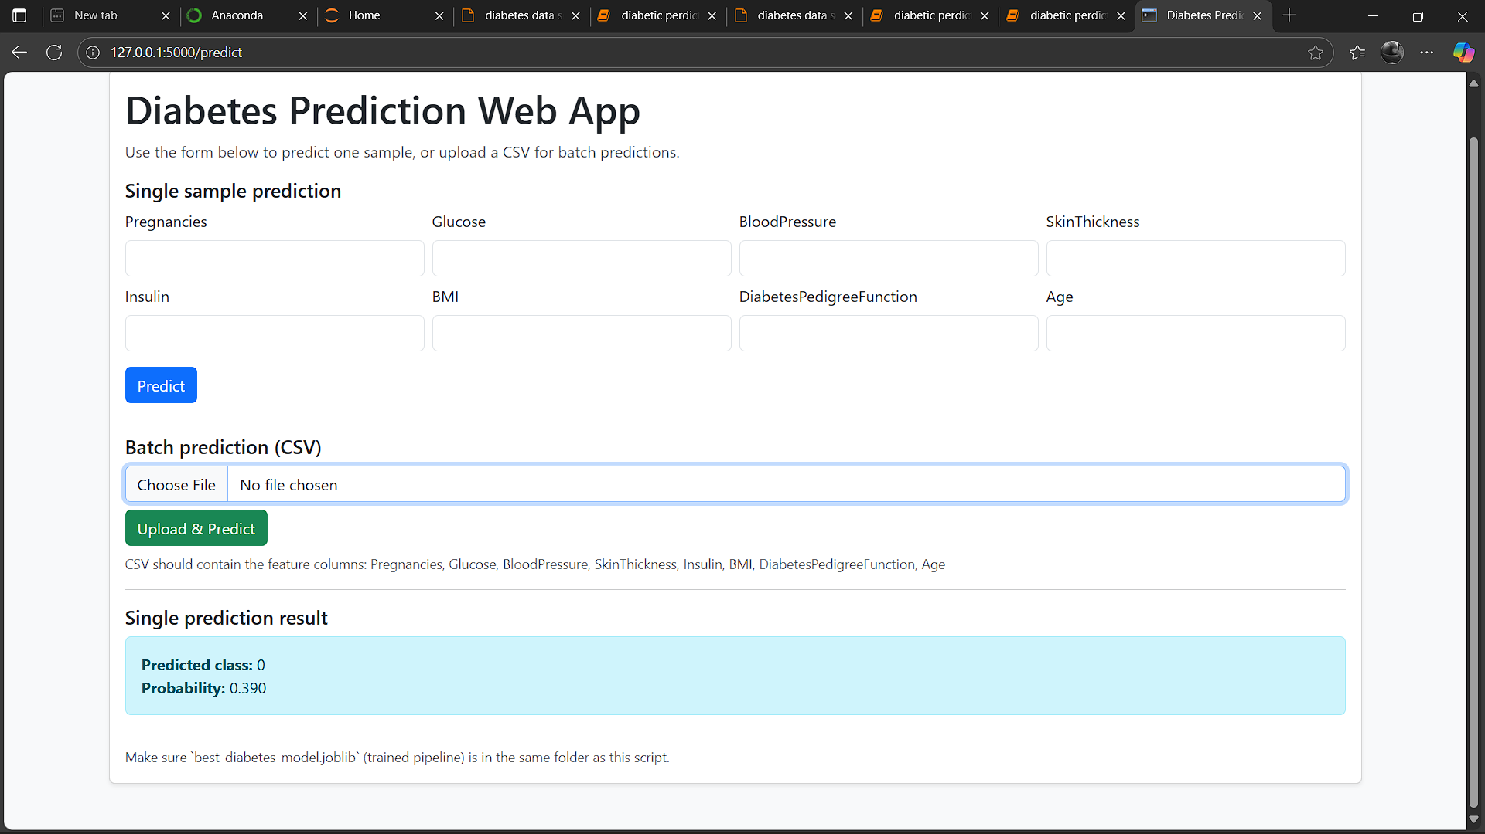

Conclusion
The project “Diabetes Prediction using Machine Learning” successfully demonstrates how data-driven approaches can assist in the early detection of diabetes. By analyzing medical parameters such as glucose level, BMI, blood pressure, insulin, and age, machine learning models can predict the likelihood of diabetes with a significant degree of accuracy.
Among all the models implemented, the Random Forest Classifier achieved the highest accuracy and proved to be the most reliable algorithm for this dataset. The model’s performance highlights the importance of ensemble learning methods in handling real-world healthcare data.
The integration of a Flask-based web application further enhances the usability of the system, allowing users to easily input their health details and receive instant predictions. The addition of interactive data visualizations also helps in understanding patterns and relationships between various health indicators.
This project emphasizes that the use of machine learning in healthcare can play a vital role in early diagnosis, prevention, and awareness. With further improvements—such as incorporating larger datasets, deep learning models, and real-time health monitoring—the system can evolve into a more powerful and accurate diagnostic tool.

Future Scope
The current project provides an effective solution for predicting diabetes using machine learning techniques. However, there are several directions in which this work can be further improved and expanded:
- Integration with Real-Time Data:
The model can be enhanced by connecting it with wearable health devices or mobile apps that track glucose levels, heart rate, and physical activity in real time.
- Use of Deep Learning Models:
Future versions can incorporate deep learning architectures such as Artificial Neural Networks (ANN) or Convolutional Neural Networks (CNN) for improved accuracy and feature extraction.
- Larger and More Diverse Dataset:
Expanding the dataset with samples from different age groups, regions, and ethnic backgrounds can make the model more generalizable and reliable.
- Explainable AI (XAI):
Integrating explainability tools will help doctors and users understand why a particular prediction was made, building more trust in AI-driven diagnosis.
- Mobile and Cloud Deployment:
Deploying the application on mobile platforms or cloud-based services can make it accessible to a wider audience, especially in remote or rural areas.
- Integration with Electronic Health Records (EHR):
Linking patient records can enable automatic data retrieval and personalized health recommendations.

References
- Pima Indians Diabetes Database. UCI Machine Learning Repository.
https://archive.ics.uci.edu/ml/datasets/Pima+Indians+Diabetes
- Kuhn, M., & Johnson, K. (2013). Applied Predictive Modeling. Springer.
- Han, J., Kamber, M., & Pei, J. (2011). Data Mining: Concepts and Techniques. Elsevier.
- Pedregosa, F., Varoquaux, G., Gramfort, A., et al. (2011). Scikit-learn: Machine Learning in Python. Journal of Machine Learning Research, 12, 2825–2830.
- American Diabetes Association (ADA). Diabetes Facts and Figures.
https://www.diabetes.org/resources/statistics/statistics-about-diabetes
- Brownlee, J. (2020). Machine Learning Mastery with Python: Understand Your Data, Create Accurate Models, and Work Projects End-to-End. Machine Learning Mastery.

